**Home work:**

**CREATE AN INSTANCE , INSTALL HTTP SERVER - INSTEAD OF HELLO WORD ENTER YOUR ROLLNUMBER**

**Instance created :** **Instance02-004**

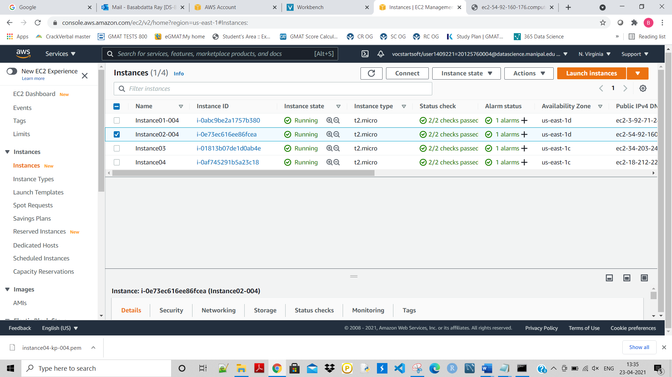

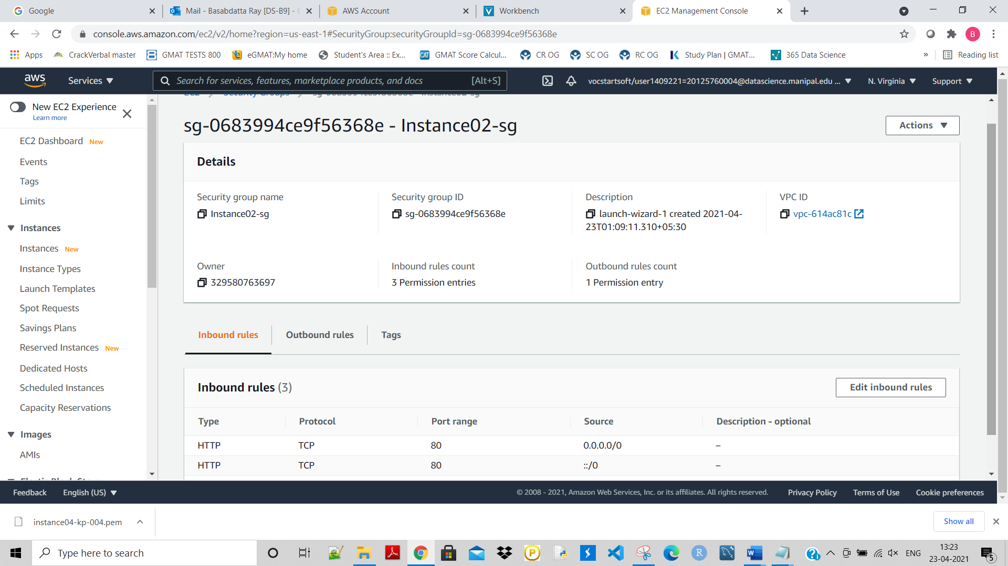

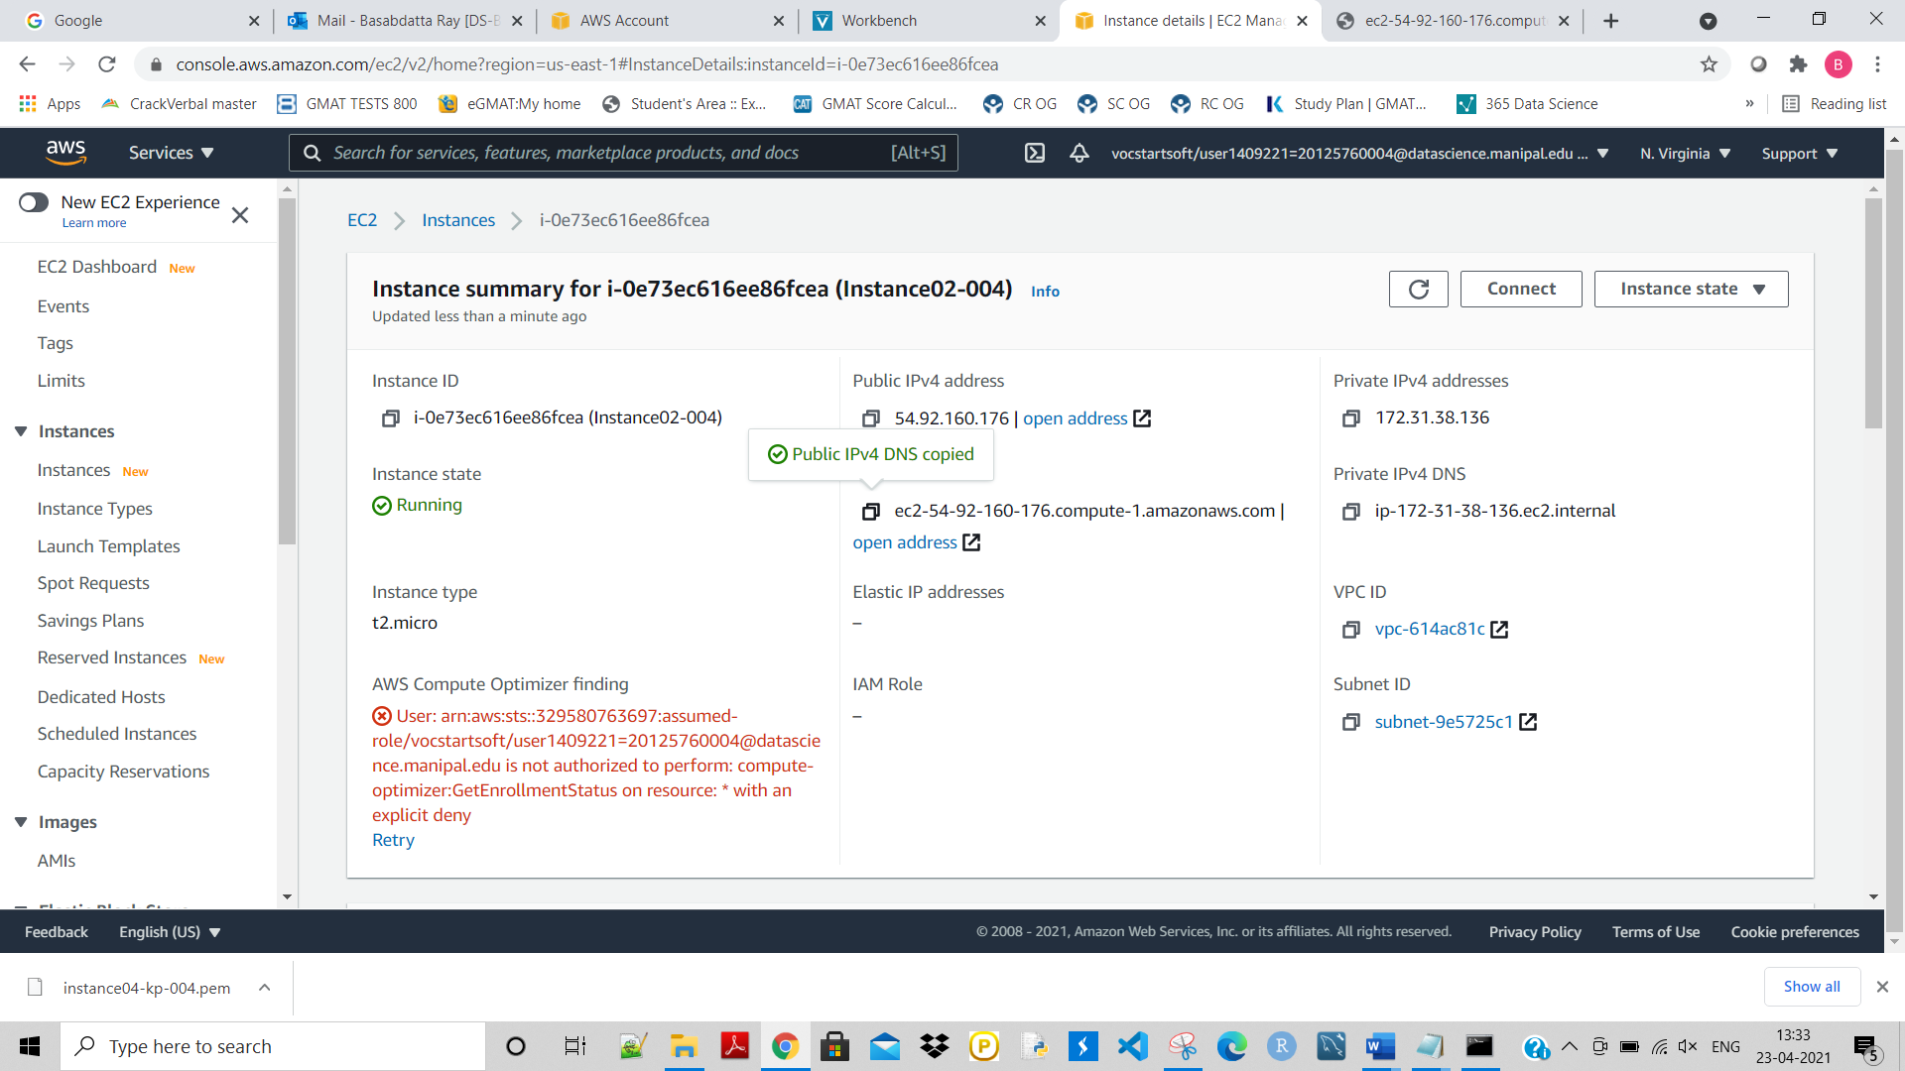

**Installed HTTP server.**

**Then modify the content as my ‘Roll number’ reflected below:**

